**Possible problems for drop in user activity post August in Yammer:**

1. **How many working/business days are there in August?**

Is it because July has had more business days than August.

1. **Decrease in mobile phone activity:**

Does Yammer have a mobile phone application? If so, then the drop may correspond to some functional/performance failure in the mobile phone application because of which users stopped using the mobile application and started using the website instead.

1. **Feedback :**

It is just as important to know who your users are as where they are coming from.  
Depending on which type of user has declined, you can isolate certain reasons for the traffic drop. For instance, if new user numbers have taken a hit there could be an issue with what kind of feedback is being communicated by the old user to a new user.

1. **Comparing with past drops:**

It’s vital to look at the big picture when it comes to traffic drops. Head over to your date range and really zoom out. Look at the past 6 months, or year even, to see if a traffic drop had occurred during a similar time in the past. You can compare time periods using the compare tool in the Google Analytics calendar, which lets you look at previous weeks, months, or similar time points in the past year in cases of seasonality. This allows you to see any trends or notable differences in user behavior or traffic sources.

1. **Possibility of a harmful activity or malfunctions on the site.**

**Hypothesis 1:**

In order to investigate the first hypothesis we need to first calculate the number of weekends/holidays in a month. We can do so by running the following query:

**select**

**(next_day(last_day(trunc(sysdate)),'日')-7**

**-next_day(trunc(sysdate,'mm')-1,'日'))/7+1**

**as "sundays"**

**from dual;**

**sundays**

**-------**

**5**

**In order to answer the first question, we can observe the following graph:**

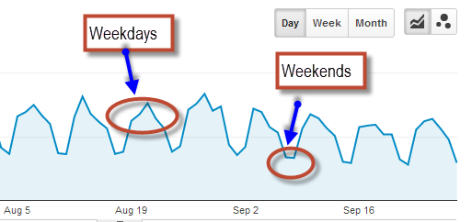

**Hypothesis 2:**

In order to debug the second problem, we can glance over the number of downloads of Yammer mobile phone application. If there is a decrease we need to review the comments.

Now this leads us to another question:

**How do we parse so much data?**

Possible Solution: We may need to perform text mining and sentiment analysis on the data.

**Hypothesis 3:**

There is no feasible way in which we can keep records of verbal communication between the users about our product. We could at most do a sentimental analysis on the user comments in various Social sites.

**Hypothesis 4:**

For comparing with past drops, we can make use of lot of available tools such as Tableau etc.

**Hypothesis 5:**

The combination of Google Analytics and Google Webmaster Tools can be a very powerful thing. Google Webmaster Tools has a messages tab that alerts you to any harmful activity or malfunctions on your site.